Jennifer Stegina

20 September 2019

CIS 250

**Unit 4 Graded Exercise 2**

The following questions come from the “Check your understanding” examples of each section of chapter 13 in your textbook.

After you are finished, please submit a Microsoft Word file that contains screenshots of the SQL queries and the output, along with a comment in the query containing your name. Your document should be named **U4_GradedExercise2_Lastname.docx**.

(13-10) Question 1:

Write a select statement to create the inner join of tables *sec1310_table1* and *sec1310_table2*. The join condition should say that the first three columns of these tables are equal.

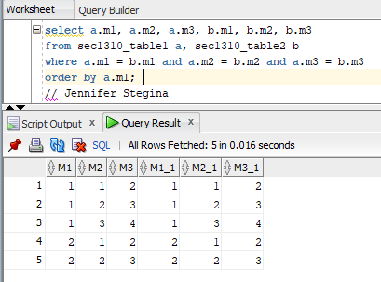

~~(10-11)~~ (13-11) Question 2:

A large dictionary has four volumes. Table *sec1311_dictionary* shows the range of words that are in each volume. Table *sec1311_words* contains some words that are in the dictionary. Write SQL to determine which volume of the dictionary contains each of these words.

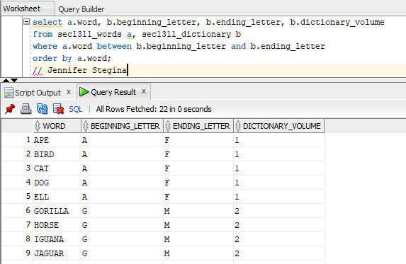

(13-12) Question 3:

List all the letters that are greater than S. Use the *alphabet* table. Put these letters in order.

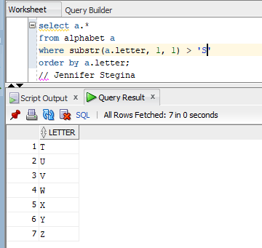

(13-13) Question 4:

Tables *sec1313_words1* and *sec1313_words2* contains words. Join these tables together when the words end in the same letter.

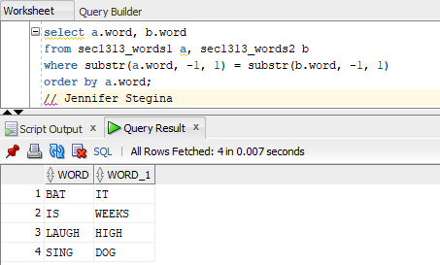

(13-14) Question 5:

Change this SQL, writing the join condition in the *from* clause.

*select a.student_name,*

*a.test_score,*

*b.letter_grade*

*from sec1311_student_scores a,*

*sec1311_grade_ranges b*

*where a.test_score between b.beginning_score*

*and b.ending_score*

*order by a.student_name;*

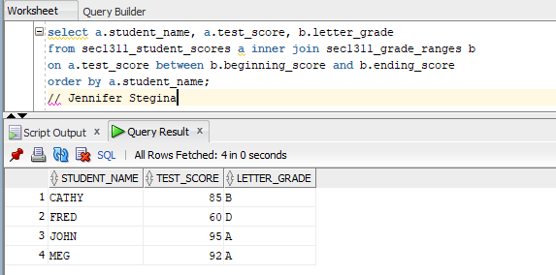

(13-15) Question 6:

Write a *select* statement to list all the foods on the lunch menu and show the full name of the supplier of each food.

(13-16) Question 7:

Demonstrate that a *select* statement can be separated into two parts: The first part joins the tables and creates a new table, and the second part restricts the amount of data that is shown. For the following *select* statement, write two SQL statements to separate these two steps.

*select a.description,*

*b.supplier_name*

*from l_foods a,*

*l_suppliers b*

*where a.supplier_id = b.supplier_id*

*order* by *a.description;*

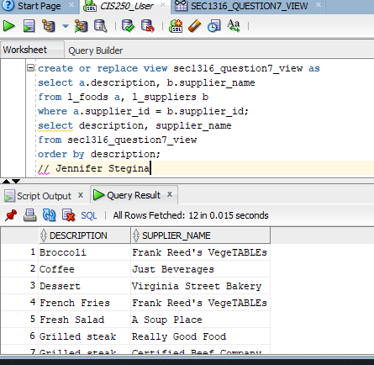

(13-17) Question 8:

List all the foods on the menu and the total number of orders for each food item. Note that broccoli does not show up in the result because no one has ordered it.

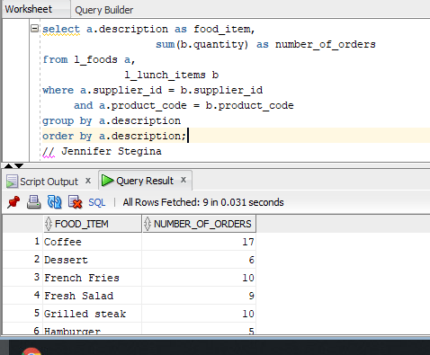

(13-19) Question 9:

Join all the tables of the *lunches* database together. Show all the columns of each table. To do this, modify the *select* statement in this section and add the three other tables to it. How many rows and columns are in this table?

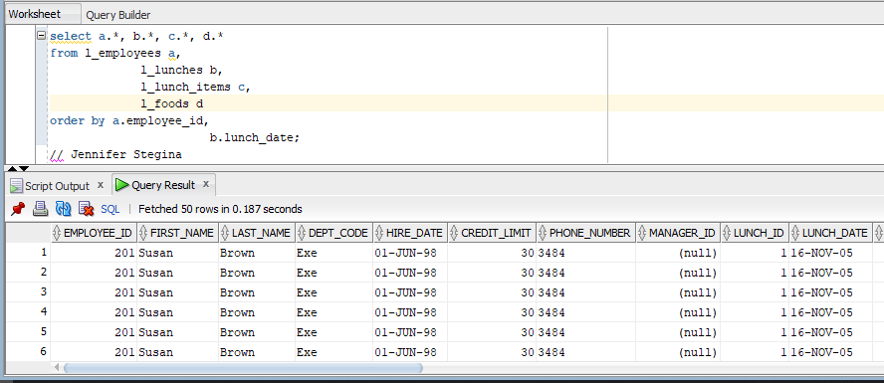

L_employees has 8 columns and 10 rows.

L_foods has 6 columns and 12 rows.

L_lunch_items has 5 columns and 71 rows.

L_lunches has 4 columns and 16 rows.

Joining them all together means there would be a grand total of 23 columns and 109 rows when l_employees, l_foods, l_lunch_items, and l_lunches are joined together.